Game programming 24/25

# 14/10/2024

Start of brainstorming for what tutorials I’m going to make,

* I’ve always been interested in parallax scrolling, it has been used by many games and gives a sense of immersion that was greatly utilised in the side scrolling games featured on the 16 bit consoles. The first notable game that comes to my mind that uses this is the original Sonic the hedgehog rom 1991.

[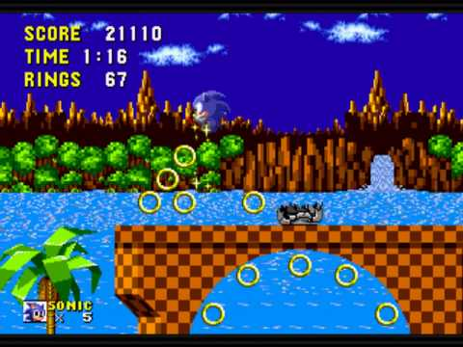](https://www.youtube.com/embed/LMasV2b6OVA?start=15&feature=oembed)

This is a walkthrough video of the first area in Sonic 1, I’d like to make something that resembles how the background feels like it is a 3d space desite the fact that it is only using 2d elements. The forced camera perspective aides this as it means that the player’s view of the game is locked to only see what the developers want them too.

* Another feature that I am looking at seen in 2d platformers are tilting platforms, platforms such as these are interesting from ma coding standpoint as well as from a gameplay standpoint. They can either be controlled via a feature of the, as seen with the motion controls of New Super Mario Bros Wii, or they can either be controlled via the player’s weight. Using the player's weight would mean that the player would have to have a value for it however it adds more obstacles that can be added such as moveable crates and objects that react to the player such as breakable ground objects